NAME: BANDA VARSHITHA
ENROLL NO:2503B09913

Set 5
- Q1. Generate Python code for the Fibonacci sequence with Cursor AI. Refine your prompts to handle only positive integers and record the changes and outcomes.
(Each question carries 5 marks)
PROMPT: Generate Python code for the Fibonacci sequence that validates n is a positive integer
CODE:
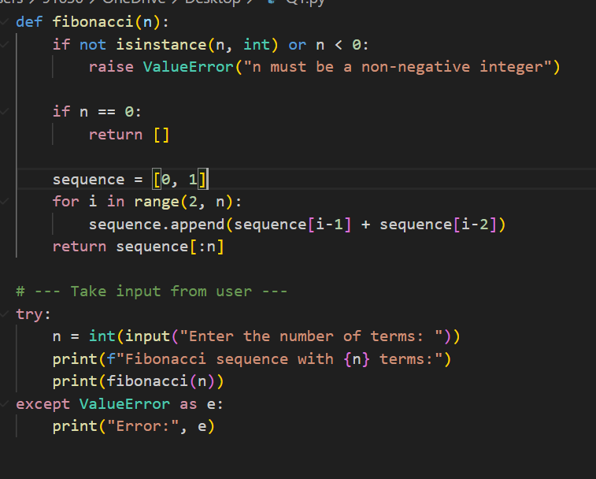
OUTPUT:
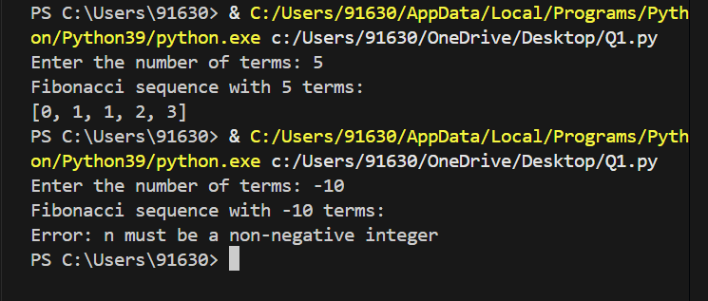

- Q2. Write a Python queue class (`enqueue`, `dequeue`, `peek`). Use an AI assistant and test the class with multiple scenarios. Describe how AI-generated code manages edge cases and how you improved it.
(Each question carries 5 marks)
PROMPT: Write a Python class for a queue with enqueue, dequeue, and peek methods.
CODE:
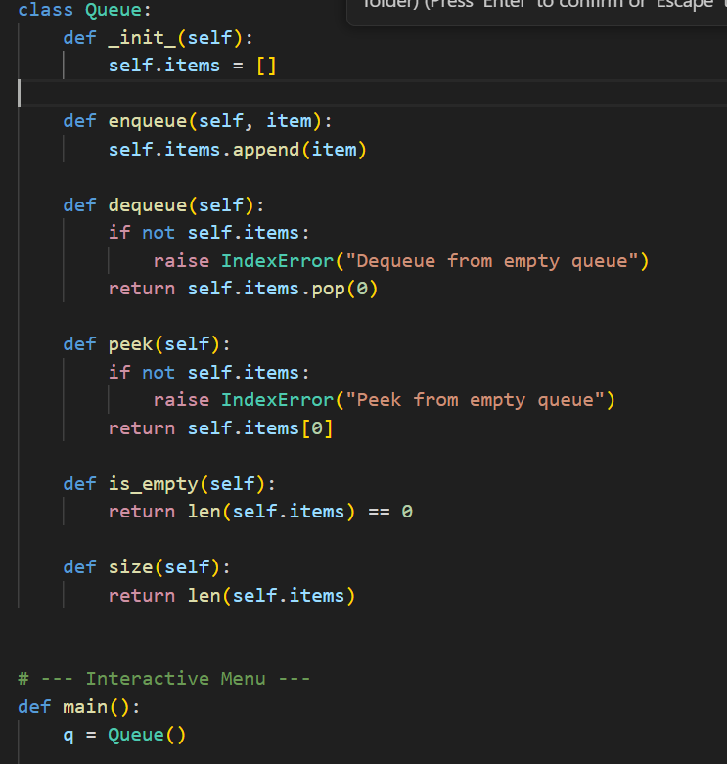
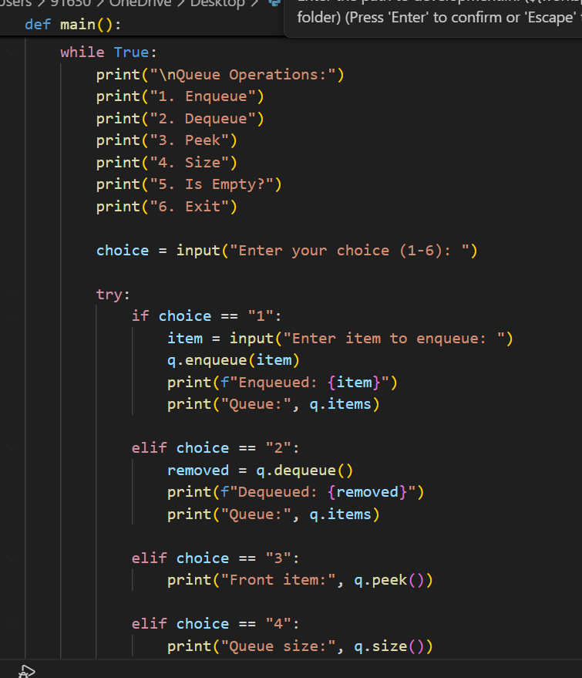
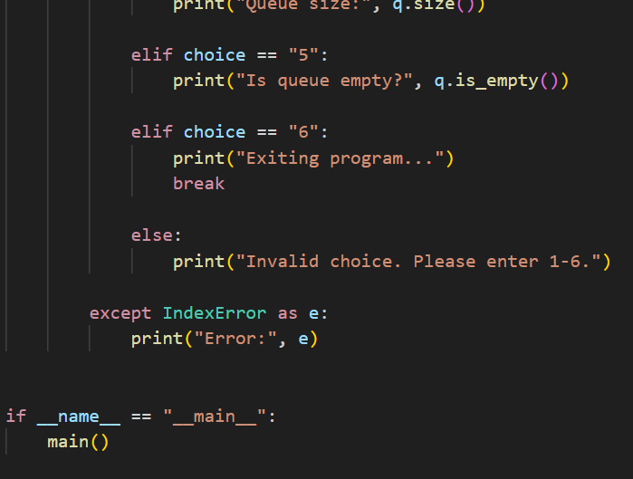
OUTPUT:
